Department of computer science



Software Engineering Lab

Project (Sprint 0): **Car Dealership System**

**Group 5**

Waqar Bashir 161104

Usman Nawazish 161122

Hamza Ali 161124

Minhaj Ahmad 161150

Submitted to Mam Aatka Ali

Introduction:

The aim of this project is to develop a car dealership system.This application stores the information about customers, dealers and car details. It also stores the data about sale and purchase of cars. In this context the functionality is to insert , update and delete the records and vice versa.

The core functionality of this project is:

* Add, update and delete customer information
* Add, update and delete Dealer information
* Add, update and delete information about purchased and sale cars.
* Store the record of all cars.

**Some of the main functionalities and Entities of the system are as follow:**

* Customer
* Dealer
* Car details
* Purchase
* Sale

Domain Model

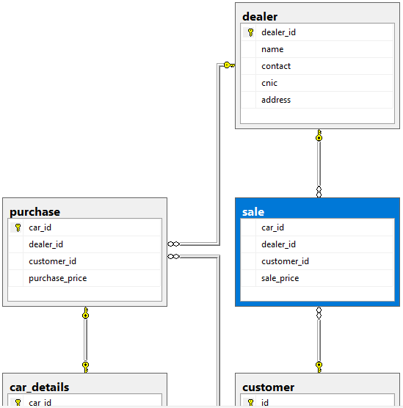 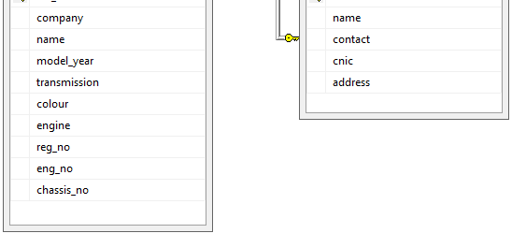

ERD Model:

Customer

Car details

Dealer

Sell

Purchase